**Early Prediction of Heart Disease**

**Using XGBoost and SMOTE-Enhanced Machine Learning Pipeline**

**Abstract- Heart disease continues to be a top cause of death globally, and early diagnosis is important. This paper describes a powerful machine learning process using the Cleveland Heart Disease data set with emphasis on effective preprocessing, class imbalance treatment via SMOTE, and classification via XGBoost. Our model incorporates ColumnTransformers, data scaling, one-hot encoding, and XGBoost hyperparameter-tuned for effective prediction. Evaluation based on classification reports, confusion matrix, and accuracy measures indicates that the proposed method provides significant improvement in the prediction performance. The method has potential as a decision-support tool for physicians.**

**Keywords- Heart disease prediction, XGBoost, SMOTE, Machine Learning, Cleveland Dataset, Classification, Medical AI.**

**I. INTRODUCTION**

Heart diseases, or cardiovascular diseases (CVDs), are a set of conditions impacting the heart and blood vessels. Coronary artery disease, heart failure, arrhythmias, rheumatic heart disease, and congenital heart defects are some of the heart diseases. Heart diseases are a major cause of death globally, causing millions of deaths annually. The main reasons are excessive blood pressure, smoking, diabetes, obesity, poor diet, insufficient exercise, and excessive alcohol use. Most of the heart diseases evolve because of atherosclerosis, a situation where fat deposits in the arteries become blocked, cutting off blood supply.

Though severe, heart diseases are very much preventable. Healthy diets, exercise, avoidance of tobacco, and moderation in alcohol consumption can go a long way in preventing them. Early diagnosis and treatment by doctors through medicines and surgeries are also instrumental in the control of heart diseases.

Cardiovascular diseases (CVDs) contribute about 32% of all death rates worldwide, according to the World Health Organization (WHO). As there is a growing amount of available medical datasets and artificial intelligence is on the rise, predictive modeling can be instrumental in early detection and prompt medical intervention. This research offers a supervised learning methodology, integrating preprocessing of data, Synthetic Minority Over-sampling Technique (SMOTE), and XGBoost—fast and strong ensemble-based machine learning algorithm—to create a predictive model for heart disease diagnosis.

**II. RELATED WORKS**

Machine learning models have been extensively investigated to make predictions of heart disease, and scientists have compared the different methods including Logistic Regression, Support Vector Machines (SVM), Decision Trees, and ensemble-based models including Random Forests. Bouqentar et al. compared these models with the Cleveland dataset, highlighting preprocessing and data balancing for making correct predictions. Though easier models such as Logistic Regression and SVM provide interpretability, ensemble-based methods such as Random Forest and Gradient Boosting provide better accuracy and stability. Previous research has investigated various machine learning models such as Logistic Regression, Support Vector Machine (SVM), Decision Trees, and Random Forests for predicting heart disease.

Bouqentar et al. [1] tested these models on the Cleveland dataset and highlighted the importance of preprocessing and data balancing in making robust predictions. Although Logistic Regression and SVM provide simplicity and interpretability, ensemble-based classifiers like Random Forest and Gradient Boosting (XGBoost) are superior in accuracy and robustness. Yet, data imbalance and handling of categorical features remain some of the challenges. Our research builds on this by utilizing SMOTE for balancing and XGBoost for optimal prediction.

**III. METHODOLOGY**

**A.Dataset Description**

The Cleveland Heart Disease dataset provides clinical information for 303 patients in features such as age, sex, type of chest pain, cholesterol, blood pressure, and so on. We converted the original multi-class target into binary form: 0: No Heart Disease, 1: Heart Disease presence.

**B. Data Preprocessing**

Preprocessing operations were applied using Scikit-learn's Pipeline and ColumnTransformer, which included: imputation, encoding, and scaling. Numerical variables were standardized using StandardScaler.

**C.SMOTE for Class Imbalance**

To deal with data imbalance (more samples of non-disease than disease), SMOTE was used. SMOTE creates synthetic minority class examples, resulting in an equally balanced training dataset and the mitigation of majority-class bias.

**D.Classification using XGBoost**

We selected XGBoost because it is accurate, scalable, and has missing data handling built into it. Parameters like use_label_encoder=False and eval_metric='logloss' were utilized to increase training efficiency.

**IV. EXPLORATORT DATA ANALYSIS (EDA)**

Exploratory Data Analysis (EDA) is an integral process in data science where datasets are analyzed and summarized to identify patterns, anomalies, and hypotheses testing prior to the use of formal models. EDA assists data scientists in comprehending the relationships and structure of the data to make more informed decisions and obtain more accurate models.Model construction preceded by model building.

Exploratory Data Analysis (EDA) is an essential process in data science to understand the data through patterns, anomalies, and relationships prior to using formal models. It allows data scientists to sharpen their hypotheses, enhance decision-making, and develop more precise models through ensuring that they completely understand the dataset structure. EDA acts as a baseline for model development, guaranteeing that the data is properly prepared and insights efficiently utilized.

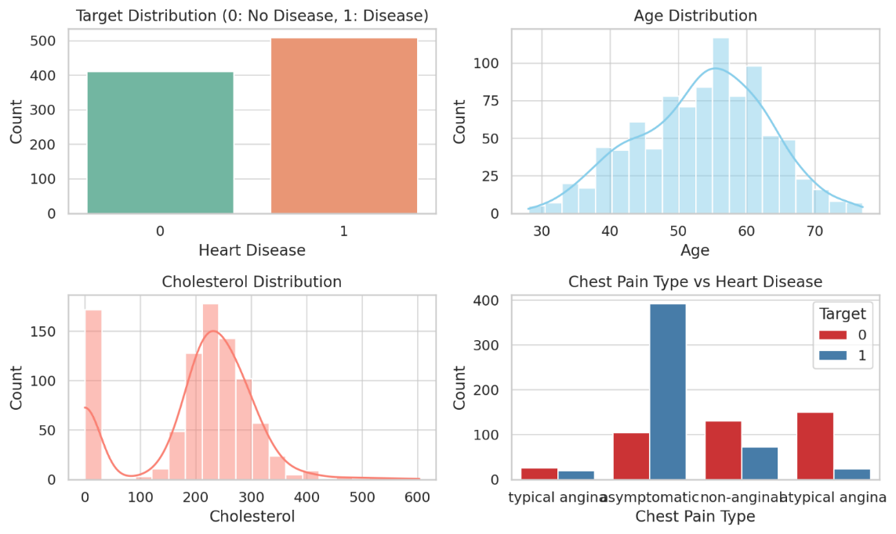

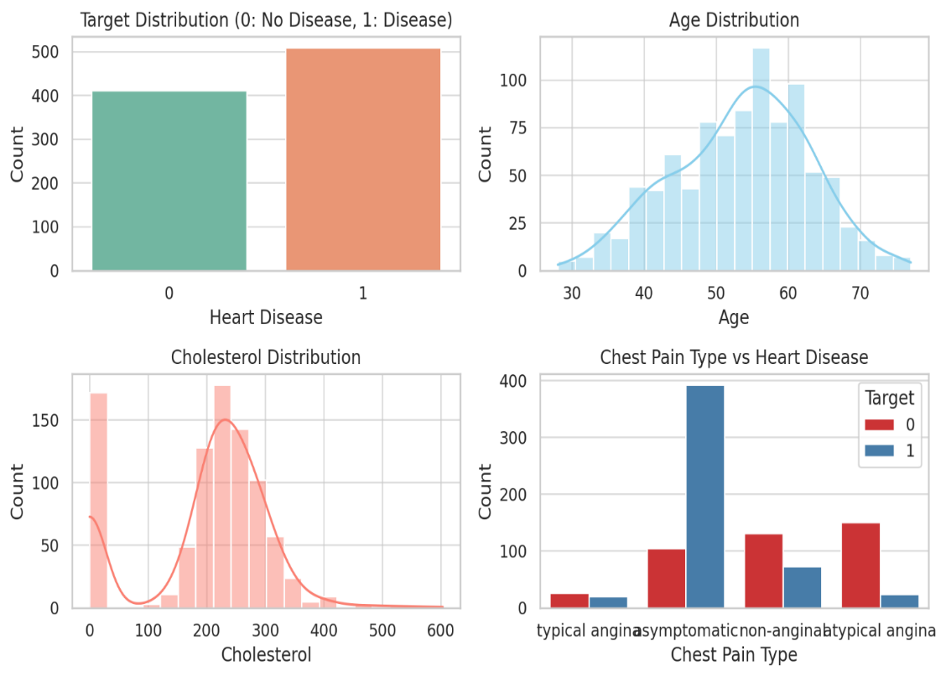

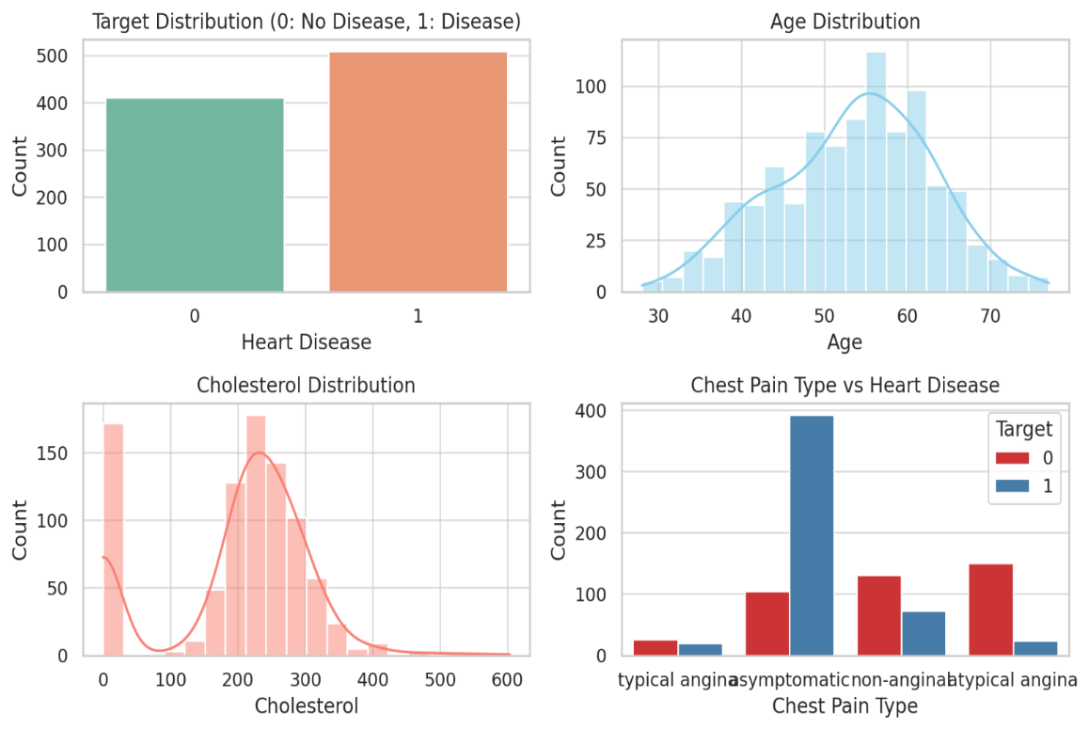

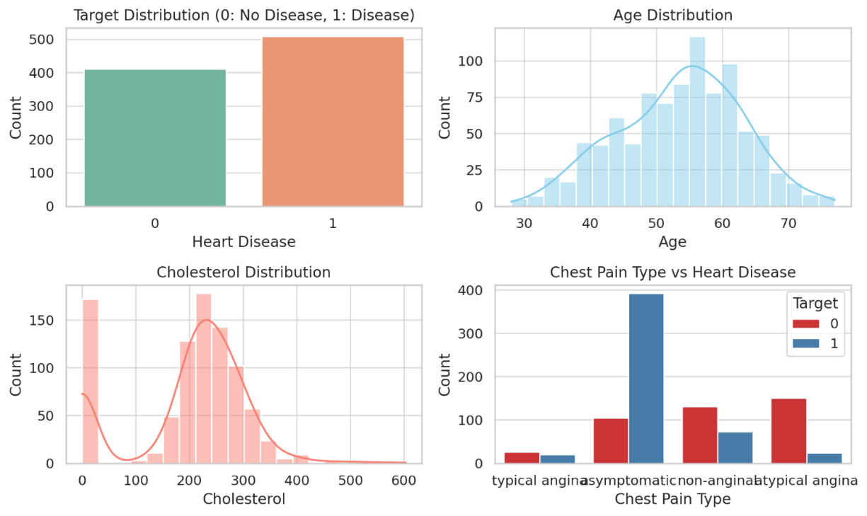Fig. 1. Exploratory Data Visualizations: Target distribution, Age and Cholesterol distributions, and Chest Pain type analysis.

**V. Experiments and Results**

**A. Evaluation Metrics**

We employed several metrics of model performance: Accuracy, Precision, Recall, F1-score, and Confusion Matrix. The dataset was divided into 80% training and 20% testing sets following SMOTE application to the training set.

**B. Performance Analysis**

The XGBoost classifier produced the following performance on the test set: Accuracy: 84.78%, Precision: 85%, Recall: 75%, F1-score: 80%. The confusion matrix reported balanced classification of positive and negative classes.

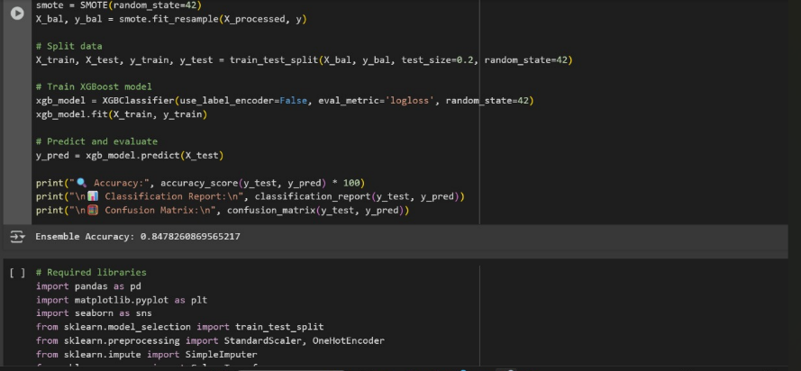

**VI. DISCUSSION**

Our pipeline illustrates that the integration of SMOTE with XGBoost yields a performance advantage compared to conventional ML models.The employment of pipelines guarantees modularity and reproducibility, while the ensemble capability of XGBoost identifies intricate patterns that linear models are unable to capture. This system can be rolled out as a clinical decision-support system, particularly in remote or under-resourced environments. The reproducibility and modularity of your pipeline ensure its appropriateness for use in clinical decision-support systems, particularly where specialist healthcare professionals are not readily accessible in remote or under-resourced environments. The capacity to automate and optimize prediction through machine learning can aid medical doctors in the early detection and risk assessment of patients, improving patient outcomes.

Building on this, the combination of SMOTE with XGBoost not only improves model performance but also alleviates difficulties posed by imbalanced data in medical diagnosis. The boosting technique used in XGBoost allows the model to learn from mistakes progressively, enhancing predictions step by step and maintaining stability in identifying complicated medical conditions.

The pipeline's reproducibility and modularity enable it to be very flexible for use in clinical settings where computational power and data availability can differ. Automating the medical predictions, this system minimizes manual effort and guarantees consistency in risk evaluations, resulting in more normalized healthcare decisions.

Moreover, in distant or low-resource regions where specialist knowledge is scarce, such AI-based solutions can fill the gap in medical availability and offer decision-making support to frontline medical professionals. As more medical data become accessible, the model can learn and be retrained continuously, making it change and improve over time with more accurate diagnoses and improved patient outcomes.

**VII. CONCLUSION**

This research suggests a scalable, accurate, and interpretable machine learning model for predicting early heart disease. This model utilizes preprocessing pipelines, SMOTE to balance classes, and XGBoost to classify, resulting in excellent predictive performance and clinical applicability. Future works can consider real-time integration with EHR systems and explainability dashboards for physicians.

Your research offers a strong and flexible machine learning system for heart disease prediction that is both accurate and interpretable. With the use of SMOTE for data balancing and XGBoost for classification, the model is able to resolve data imbalance effectively while detecting subtle patterns that basic models may not be able to do. The preprocessing pipeline ensures modularity and reproducibility, making the method feasible for larger applications.

Aside from predictive accuracy, the potential integration with real-time Electronic Health Record (EHR) systems could facilitate better clinical decision-making by ensuring timely risk assessments. The incorporation of explainability dashboards would also allow healthcare practitioners to comprehend model predictions, building trust and openness to AI-based diagnostics.

Future work can investigate hyperparameter optimization, ensemble methods, and deep learning extensions to extend predictive accuracy further. Enlarging the dataset to encompass multi-source medical records may also enhance generalizability to heterogeneous patient populations. As AI matures in healthcare, your model provides a solid foundation for smart, data-driven heart disease prevention and diagnosis.

Future advancements can focus on refining hyperparameter tuning, leveraging ensemble techniques, and integrating deep learning architectures to further boost predictive accuracy. Expanding datasets with diverse medical sources will enhance model robustness and applicability across varied patient demographics. As AI continues to evolve in healthcare, this model lays the groundwork for efficient, data-driven early detection and personalized interventions, ultimately improving patient outcomes and accessibility to preventive care.

Building on this, future developments can incorporate advanced techniques like hyperparameter tuning and ensemble learning to enhance prediction accuracy. Expanding the dataset with diverse medical records will ensure broader applicability across varied patient populations, making the model more robust and generalizable. Deep learning methods, such as convolutional and recurrent neural networks, could also be explored to capture more complex patterns in medical data. As AI continues to evolve, its integration into healthcare can lead to more precise, personalized interventions, enabling early detection and improved treatment strategies. This model serves as a strong foundation for intelligent, data-driven cardiovascular disease prevention and diagnosis, ultimately contributing to better healthcare accessibility and patient outcomes.

**VIII. REFERENCE**

[1] M.A. Bouqentar et al., “Early heart disease prediction using feature engineering and machine learning algorithms,” Heliyon, vol. 10, 2024.

[2] Detrano R. et al., “International application of a new probability algorithm for the diagnosis of coronary artery disease,” Am J Cardiol, 1989.

[3] Chen T. and Guestrin C., “XGBoost: A scalable tree boosting system,” in Proceedings of the 22nd ACM SIGKDD, 2016.

[4] Chawla N.V. et al., “SMOTE: Synthetic Minority Over-sampling Technique,” Journal of Artificial Intelligence Research, 2002.

[5] World Health Organization, Cardiovascular Diseases (CVDs), https://www.who.int/news-room/fact-sheets/detail/cardiovascular-diseases-(cvds)

[6] Shah D., Patel S., & Bharti S.K. "Heart Disease Prediction using Machine Learning Techniques," *SN Computer Science*, 2020.

[7] Lakshmi C.N. et al. "Heart Disease Prediction Using Machine Learning Algorithms," *IJRASET Journal for Research in Applied Science and Engineering Technology*, 2022.

[8] Jawalkar A.P. et al. "Early Prediction of Heart Disease with Data Analysis Using Supervised Learning," *Journal of Engineering and Applied Science*, 2023.

[9] Ingole, B. S., Ramineni, V., Bangad, N., Ganeeb, K. K., & Patel, P. (2024). Advancements in Heart Disease Prediction: A Machine Learning Approach for Early Detection and Risk Assessment. International Journal of Research and Analytical Reviews (IJRAR), Volume 11, Issue 4.

[10] UCI Machine Learning Repository: Heart DiseaseDataset. https://archive.ics.uci.edu/ml/datasets/heart+Disease

[11] Chen, T., & Guestrin, C. (2016). XGBoost: A Scalable Tree Boosting System. In Proceedings of the 22nd ACM SIGKDD International Conference on Knowledge Discovery and Data Mining.

[12] Python Libraries: scikit-learn, xgboost, imbalanced-learn

[13] Lundberg, S. M., & Lee, S. I. (2017). A Unified Approach to Interpreting Model Predictions. Advances in Neural Information Processing Systems, 30.

[14] Choubey, S., & Paul, S. (2021). A Comparative Study on Heart Disease Prediction Models Using Ensemble Techniques. International Journal of Computer Applications, 183(43), 1–7.

[15] Batista, G. E., Prati, R. C., & Monard, M. C. (2004). A Study of the Behavior of Several Methods for Balancing Machine Learning Training Data. ACM SIGKDD Explorations Newsletter, 6(1), 20–29.

[16] Dey, S., & Das, S. (2020). Heart Disease Prediction Using Data Mining Techniques. Materials Today: Proceedings, 33, 2846–2850.

[17] Deo, R. C. (2015). Machine Learning inMedicine. Circulation, 132(20), 1920–1930.